Type  Main technical parameter |  | JW-89
Profile yield limit |  | σ_{s}≤245MPa
angle iron incurvature | 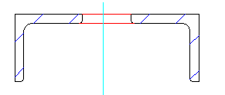 | Max section | 75×75×10
angle iron incurvature |  | Min bending dia. | 1200
angle iron incurvature |  | Min section | 35×35×3
angle iron incurvature |  | Min bending dia. | 560
angle iron excurvature | 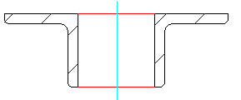 | Max section | 90×90×10
angle iron excurvature |  | Min bending dia. | 1150
angle iron excurvature |  | Min section | 35×35×3
angle iron excurvature |  | Min bending dia. | 500
Channel steel excurvature | 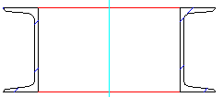 | model | 16#
Channel steel excurvature |  | Min bending dia. | 800
Channel iron incurvature | 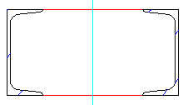 | model | 16#
Channel iron incurvature |  | Min bending dia. | 1000
Flat iron bend in hard way | 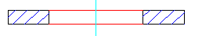 | Max section | 90×20
Flat iron bend in hard way |  | Min bending dia. | 900
Flat iron bend in easy way | 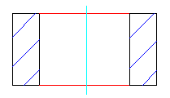 | Max section | 180×25
Flat iron bend in easy way |  | Min bending dia. | 900
Pipe | 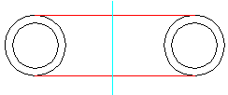 | Max section | 89×5
Pipe |  | Min bending dia. | 1000
Pipe |  | Min section | 25 x 2
Pipe |  | Min bending dia | 500
Diameter of standard module (mm) |  | 360
Rolling speed（m/min） |  | 5
Main motor power（KW） |  | 7.5

