Model  Parameter |  | JW-50
Profile yield limit |  | σs≤250MPa
Angle steel in curve | 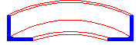 | Max. section | 45×45×5
Angle steel in curve |  | Max. diameter | 700mm
Angle steel in curve |  | Min. section | 20×20×3
Angle steel in curve |  | Min. diameter | 400mm
Angle steel excavation | 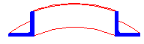 | Max. section | 50×50×6
Angle steel excavation |  | Min. diameter | 700mm
Angle steel excavation |  | Min. section | 20×20×3
Angle steel excavation |  | Min. diameter | 400mm
Channel steel in curve | 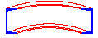 | Model | 5#
Channel steel in curve |  | Min. diameter | 560mm
Channel steel excavation | 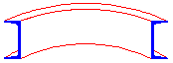 | Model | 8#
Channel steel excavation |  | Min. diameter | 500mm
flat steel vertical bend | 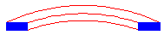 | Max. section | 50×12
flat steel vertical bend |  | Min. diameter | 500mm
Flat steel | 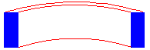 | Max. section | 100×18
Flat steel |  | Min. diameter | 500mm
Round steel | 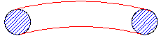 | Max. section | Φ30
Round steel |  | Min. diameter | 450mm
Steel pipe | 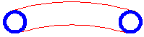 | Max. section | Φ42X3mm
Steel pipe |  | Min. diameter | 500mm
Mould diameter(standard) |  | Φ195mm
Bend speed |  | 5.5m/min
Down roller up and down speed |  | 180～200mm/min

